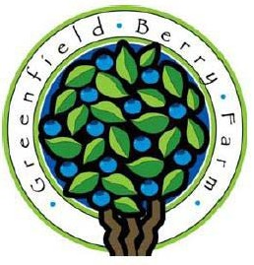**What is a CSA?**

**Greenfield Berry Farm 2025 CSA**

Community Supported Agriculture (CSA) programs unite farmers and families around fresh local food. Farmers grow a variety of vegetables in a natural, sustainable way and pick them at the peak of

flavor and nutrition. The community supports their local farmers by purchasing shares of the harvest and picking them up each week during

the growing season. Together the farmers and CSA

members share in the rewards and risks of farming.

**What is unique about this CSA?**

Located in the beautiful Cuyahoga Valley National Park, the Greenfield Berry Farm aims to provide fresh, local, and naturally grown produce to our CSA members. Unlike a traditional single-farm CSA, we can provide consistent quality, quantity, and a wider variety of produce by working with other local farmers who share our passion for small-scale farming. Most of the produce will be from our farm, but we can get items from other local farms when we have a slow week or when they have something special that we don’t. Summer CSA members also receive a $20 voucher ($10 for half-share members) for pick-your-own berries from our farm.

**What types of shares are available?**

**•** Spring share (4 weeks starting in May)

**•** Summer share (15 weeks; mid June through early October)

**•** Fall share (4 weeks in October)

**•** Half share (11 weeks; every other week starting in May)

**Please note the following:**

1. **There’s a two-week break scheduled in July (on 7/11 and 7/18), but these dates could change based on growing conditions.**
2. **The 4th of July and Halloween both fall on a Friday this year, so those pickups will be moved to Thursday of those weeks (7/3 and 10/30).**

**What can I expect in my share?**

Each week you can expect to receive a variety of fresh local vegetables, which will vary with the season. Part of the fun of belonging to a CSA is in learning how the tapestry of produce changes with the time of year and local conditions. Our goal is to provide enough produce for a family of four each week to the best of our ability.

**When and where do I pick up my share?**

You will pick up your share on Fridays between 5 and 7 pm at the farm (2485 Major Road, Peninsula).

Greenfield Berry Farm

2485 Major Road Peninsula, Ohio 44264 [www.greenfieldberryfarm.com](http://www.greenfieldberryfarm.com/)

**Shareholder Information/Agreement Form**

I understand and agree to the terms of the Greenfield Berry Farm CSA and am making a commitment to the 2025 growing season.

I recognize that there is no guarantee on the amount of produce in a week's share.

I understand that I am responsible for cleaning and proper handling after pickup.

I agree to pick up my share on the specified day and  
during scheduled hours. (If you are unable to pick up  
your share, we can hold it for you for one day, or you can  
make arrangements to have a friend or neighbor pick it up for you.)

Finally, I understand that farming comes with many risks, such as drought, floods, insect damage, etc. I am willing to share in both the risks and rewards along with the farmers and other CSA members.

Name

Phone

Email

Please check all that apply:

Spring share (4 weeks) - $150

Summer share (15 weeks for returning members) - $510

Summer share (15 weeks for new members) - $535

Fall share (4 weeks) - $150

Half share (11 weeks; every other week) - $400

Total: $

Signature

Date

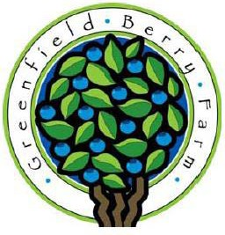**Please send a $100 deposit to secure your CSA share.**

**Greenfield Berry Farm 2025 CSA**

**Full payment is due by May 1 for spring shares, June 1 for summer shares, and October 1 for fall shares.**

Please sign and return to:

Greenfield Berry Farm 2485 Major Road Peninsula, Ohio 44264